Question 1- This is a graph that commonly appears on phone bills.
Graphs in Contexts Worksheet
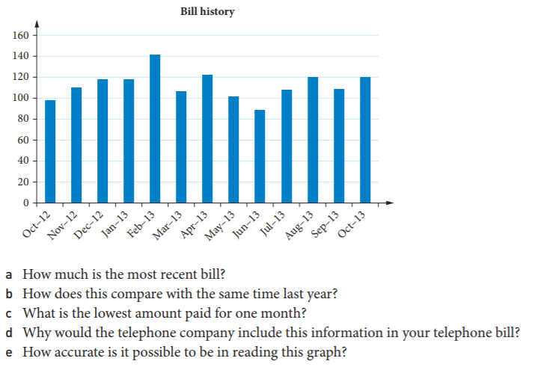
Question 2: This is a typical electricity bill graph

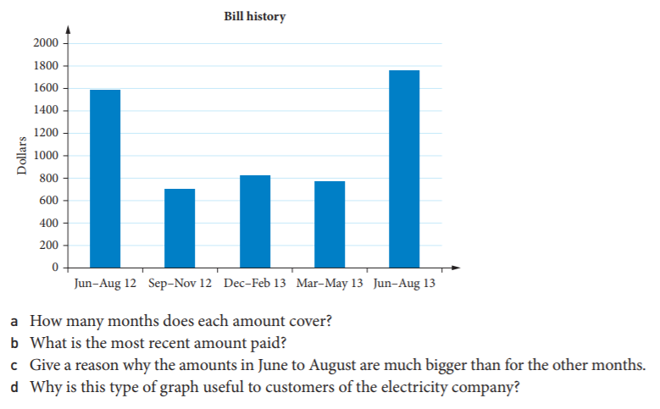

Question 3- Weather graphs often combine temperature information and rainfall information. Kalgoorlie’s climate is shown on this chart.

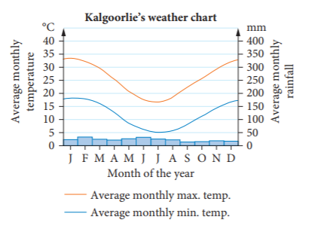 | 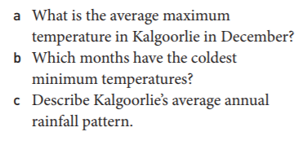

Question 4- This is a graph from the website of the Australian Red Cross
